cid:image001.jpg@01D475BA.5E929AA0

**BOARD OF TRUSTEES**

**OCTOBER MEETING MINUTES**

**Wednesday, October 23, 2024 4:00 P.M.**

**MEMBERS PRESENT:** Ron Mischke, Jenifer Shassetz, Kevin Kessner, Gene Davis, Tobie Alsup, and Richard Garber

**MEMBERS ABSENT:** Shirley Coulter

**OTHERS PRESENT:** Mike McCafferty, Nathan Stutte, Jennifer Smith, Brendon Kerns, Brittany Goodvin, Tommi Ritterbusch, Cathy Bealer, Nyle Morgan, Kelly Lieb, Dr. Doughty, Tom Ringley, Brent Maurhoff, Brady Shoemaker, Ann Aksamit, Joe Wright, Rob Forister, Kristen Czaban, Wanee Hughes, Bryan Opitz, Sean Bonnet, Payton Gambill, Jasmine Slater, Liz Dearcorn, Jessica Bettles, Dr. Sierra Gross, Tonya Carlson, Kayla Johnson, Jenny Teal, Amy Ligocki, Sharon Krueger, Erin Oetken, Dr. Shaun Gonda, Tom Klepperich and Weston Pope with the Sheridan Press

**CALL MEETING TO ORDER**

Ron Mischke, Chairman called the meeting to order at 3:59 p.m.

**PUBLIC COMMENTS, INTRODUCTIONS**

Ron Mischke recognizes and thanks Mike McCafferty for 27 years of service with Sheridan Memorial Hospital.

**APPROVAL OF AGENDA AND MINUTES**

Kevin Kessner moved to approve the agenda as presented. Gene Davis seconded the motion. Motion carried.

Jenifer Shassetz moved to approve the minutes of the board meeting held on September 25, 2024 as presented. Tobie Alsup seconded the motion. Motion carried.

**QUALITY COMMITTEE REPORT**

Kevin Kessner, Quality Committee Chair asks Tommi Ritterbusch, Director of Continuous Improvement to present a recap of the great work being done and data reviewed by the committee relevant to pain management, trauma performance metrics, pressure ulcers, alarm fatigue, employee injuries, behavioral health, tracer audits in preparation of our joint commission survey, safety events, health equity which is a new reporting infrastructure, composite scores for stroke, CHF, sepsis, and star rating education. There are no negative trends or areas of concern noted.

**PATIENT EXPERIENCE REPORT**

Kelly Lieb, Director of Patient Experience reports that the committee meeting was focused on ambulatory scores, reviewing OASCAHPS for surgical services and patient access, along with CAHPS for Hospice, all designed to measure the patient experience in the outpatient setting. Digital experience, staff engagement, and CAHPS survey response rates were discussed as well. Staff engagement correlates directly to the patient experience and great work is being done.

**MEDICAL STAFF REPORT**

Dr. Gonda reports that credentialing will be discussed in executive session and action taken after review.

Dr. Gonda, on behalf of the Medical Executive Committee and Credentials Committee recommends the following Medical Staff Initial Appointments and Medical Staff Renewals for consideration and approval.

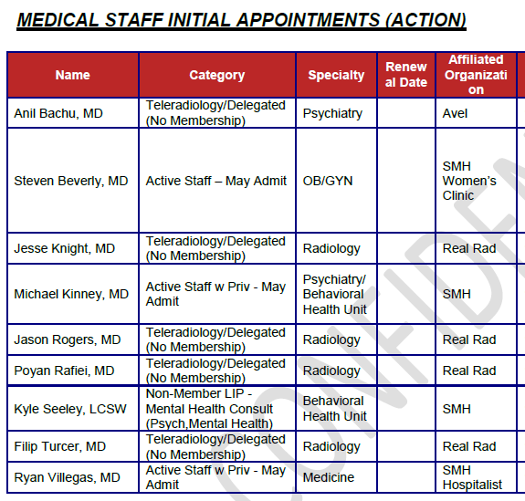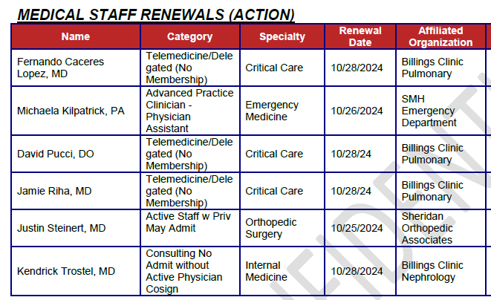

Gene Davis moved to approve the initial appointments and renewals as presented. Jenifer Shassetz seconded the motion. Motion carried.

**ADMINISTRATION REPORT**

Outpatient Imaging Update – Our team does tremendous work with patient access, process improvements, staffing and communication. Bryan Opitz is acknowledged for his leadership with the great group of people he is leading with making strides in this area.

Behavioral Health Presentation – Brittany Goodvin, Director of Behavioral Health recaps the work that is being done in preparation for the EmPATH and Crisis Stabilization Unit. An overall project plan was presented with floor plans, elevations and clinical flow, with three levels of care outlined. Dr. Kinney will begin in November, starting in an outpatient setting until the new behavioral health unit is up and running in early 2027. Nathan Stutte and the Foundation are acknowledged for their part in this huge project.

**FINANCE**

Nathan Stutte, CFO states that the first quarter has been soft with a decline in cash on hand and lower volumes across all areas. Hospital length of stays are down, as well as a slower patient visits on the clinic side, except for cardiology and general surgery. There are no indicators showing outmigration. The surgery schedule is filling up for end of year.

**FOUNDATION REPORT**

Liz Dearcorn, Director of Philanthropy reports on the 16th annual Link, Partners in Pink event that was held last weekend. The event was seamless thanks to Jasmine Slater’s organization. There were 520 participants, as well as a number of SMH staff members and volunteers. This event has become a tradition for the community to gather and celebrate, as well as a great opportunity for new participants going through their healthcare journey with cancer. The proceeds of $56,000 will go towards comfort care in support of the patients at the Welch Cancer Center.

The Foundation is continuing with tours and presentations for the campaign, 100 Donors in 100 Days. There are 38 donors so far and the campaign will end on December 3.

**BUILDING COMMITTEE REPORT**

Rob Forister, Director of Facility Services recaps the building committee meeting stating that the emergency department and pediatric unit projects are moving along nicely, as well as SameDay Health & Imaging. The EmPATH project budget will be presented for review and consideration next month. The LINAC at the Welch Cancer Center is in and we are awaiting final installation and the physicist to do final testing.

**OTHER BUSINESS**

None

**EXECUTIVE SESSION**

Ron Mischke moved into Executive Session at 4:34 p.m.

General session reconvened at 4:39 p.m. to address medical staff credentialing. Please see above under the Medical Staff Report for action taken.

Ron Mischke motioned to exit General Session and reconvene into Executive Session at 4:41 p.m. to discuss legal and personnel matters. Kevin Kessner seconded the motion. Motion carries.

General session reconvened at 5:05 p.m. with no action taken. Ron Mischke motioned to reconvene into Executive Session to further discuss personnel.

General session reconvened at 5:15 p.m. with Kevin Kessner moving to approve the agreements presented relevant to CEO contracts and compensation. Gene Davis seconded the motion. Motion carries.

**ADJOURNMENT**

With no further matters to come before the board, the meeting adjourned at 5:17 p.m.

Patty Forister, Recorder

Kevin Kessner, Secretary